THANK YOU AGAIN TO LAST YEARS SPONSORS

Youth Program Sponsors

American Bank

Applied Micro

Bill’s Plumbing and Heating

222

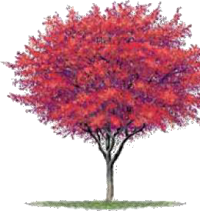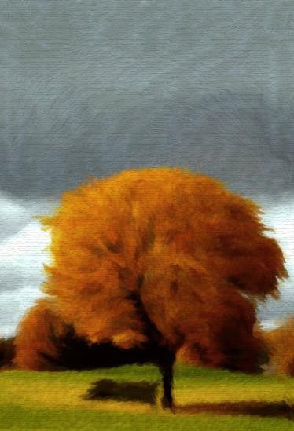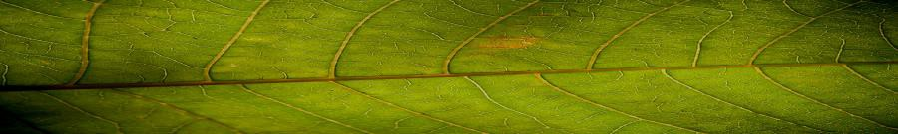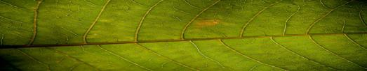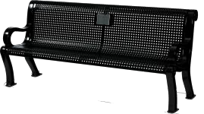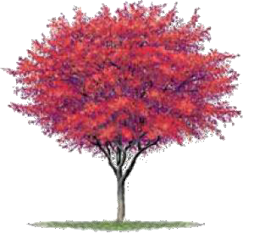

City of Platteville

75 N Bonson Street

Platteville, WI 53818

The Legacy Program provides an opportunity for groups or individuals to honor an important person or commemorate a special event. Legacy gifts of benches, trees or other park features can be made to celebrate a birth, graduation, wedding, anniversary, retirement, or in memory of a loved one. You can also leave a lasting legacy with a contribution to the Platteville Parks Endowment Fund.

**Legacy Tree**

This program allows groups or individuals to plant a tree in a park of their choosing.

Trees planted as part of this program should be suitable

for this region or selected from the recommended list.

Staff will coordinate selection, planting and maintenance of the tree.

Should the tree fail in the first year it will be replaced one time.

Someone is sitting in the shade today because someone planted a tree a long time ago.

~ Warren Buffett

**Legacy Bench**

This program allows groups or individuals to

place a bench in a park or along a trail.

Benches purchased as part of this program will be from the *Wabash Valley Estate* collection and include with a 4” x6” plaque.

**Platteville Parks Endowment Fund**

The endowment fund will provide a permanent source of funding to support parks, trails, and recreation within our community. Donations to the fund can be one-time, reoccurring or planned gifts in the form of a bequest or estate gift.

**Contact Information**

**Platteville Parks & Recreation**

**Legacy Program**

**Name: Phone: Email: Address: City: State: Zip Code:**

**Dedication**

***In Honor of In Memory of To Commemorate***

***Other***

*All language used on plaques is limited to 60 characters and subject to approval.*

**Donation**

**Recommended Large Trees**

*(over 50 feet tall)*

**AMERICAN LINDEN** *Tilia americana*

**BALDCYPRESS** *Taxodium distichum*

**BLACK HILLS SPRUCE** *Picea glauca var. densata*

**BUR OAK** *Quercus macrocarpa* **CHINKAPIN OAK** *Quercus muehlenbergii* **CUCUMBERTREE** *Magnolia acuminata*

**DAWN REDWOOD** *Metasequoia glyptostroboide*

**GINKGO** *Ginkgo biloba* **HACKBERRY** *Celtis occidentalis* **HONEYLOCUST** *Gleditsia triacanthos* **HYBRID ELM** *Ulmus species*

**KATSURA TREE** *Cercdiphyllum japonicum* **KENTUCKY COFFEETREE** *Gymnocladus dioicus* **PLANETREE** *Platanus x acerifolia*

**RED CEDAR** *Juniperus virginiana*

**Legacy Tree (New Planting)**

*$350 per tree*

**Legacy Tree (Existing Tree)**

*$150 per tree*

***Tree Species***

**1st Choice:**

**2nd Choice:**

***Planting Location***

**1st Choice:**

**2nd Choice:**

*Trees are not personalized with an onsite plaque.*

*We hope to incorporate legacy trees onto our website.*

**Legacy Bench**

*$2500 per bench*

***Desired Location***

**1st Choice:**

**2nd Choice:**

**Parks Endowment Fund**

*Any Amount*

**Amount Enclosed:**

**Payment**

***Please return this donation form to the Parks, Forestry, and Recreation Department. Checks can be made payable to:***

***CITY OF PLATTEVILLE P.O. BOX 708***

***PLATTEVILLE, WI 53818***

***\*\*\*\*\*\*\*\*\*\*\*\*OFFICE USE ONLY\*\*\*\*\*\*\*\*\*\*\*\****

**RED OAK** *Quercus rubra* **SHAGBARK HICKORY** *Carya ovata* **SWAMP WHITE OAK** *Quercus bicolor* **TAMARACK** *Larix laricina*

**WHITE PINE** *Pinus strobus*

**Recommended Medium Trees**

*(30 to 50 feet tall)*

**EUROPEAN HORNBEAM** *Carpinus betulus* **IRONWOOD** Ostrya verginiana **LITTLELEAF LINDEN** *Tilia cordata*

**OHIO BUCKEYE** *Aesculus galabra* **ORNAMENTAL PEAR** Pyrus ussuriensis **RIVER BIRCH** *Betula nigra*

**TURKISH FILBERT** Corylus colurna

**Recommended Small Trees**

*(under 30 feet tall)*

**AMERICAN HORNBEAM** *Carpinus caroliniana* **AMUR CHOKECHERRY** Prunus maackii **COCKSPUR HAWTHORN** Crataegus crus-galli **ORNAMENTAL CRAB APPLES** Malus species **SERVICEBERRY** Amelanchier species **JAPANESE TREE LILAC** Syringa reticulate **HAWTHORN (thornless)** Crataegus species

***If you have any questions please call us at:***

**608 348-9741 ext 2242**

|  |  |
| --- | --- |
| ***Item*** | ***Plaque*** |
| *Ordered:* | *Ordered:* |
| *Received:* | *Received:* |
| *Installed:* | *Installed:* |

***Date Paid:***

***Number:***

Trees planted as part of the Legacy Program will meet the

standards established in all parts of the most current editions of ANSI A300 American National Standard for Tree Care Operations – Tree, Shrub and Other Woody Plant Maintenance – Standard Practices and ANSI Z133.1

American National Standard for Tree Care Operations – Pruning, Trimming, Repairing, Maintaining and Removing Trees and Cutting Brush – Safety Requirements.

***Date Notified:***

