January 14, 2025

«Property_Owners»
«Street_Address»
«City_», «State» «Zip»

Re: | Project I.D.: 5996-01-00/70
 | STH 80 to Broadway Street
 | East Main Street
 | Grant County

The City of Platteville is proposing to reconstruct East Main Street. The project is located in Section 15, T3N, R1W, City of Platteville, Grant County, Wisconsin. The project begins at the intersection of STH 80/Water Street and East Main Street and continues east approximately 0.11 miles to the intersection of Broadway Street and East Main Street.

The project is being designed by Jewell Associates Engineers, Inc., and will consist of reconstructing the roadway. Three alternatives that explore different configurations of parking and sidewalk widths will be presented by Jewell Associates Engineers, Inc. The box culvert under East Main Street will be realigned and replaced. The curb & gutter, curb ramps, lighting, and storm sewer system will also be replaced. Construction is currently planned for the 2027 construction season.

On behalf of the City of Platteville, we would like to invite you to a Public Involvement Meeting for the E Main Street Roadway Reconstruction project.

The Public Involvement Meeting will be held Wednesday, February 5th, 2025, from 4:00 – 5:00 PM. The meeting will be held at the Platteville City Hall in the Common Council Chambers room, located at 75 N Bonson Street, Platteville, WI 53818.

The February 5th meeting will begin with a short presentation at 4:00 PM followed by an open house format with a variety of exhibits and maps available for review. Representatives from Jewell Associates Engineers, Inc. will be on hand to answer questions throughout the meeting. Attendees will have the option of making written or verbal comments during the gathering.

Persons with concern for or knowledge about historic buildings and structures and archaeological sites are encouraged to attend this meeting or provide comments to the local units of government or the consultant. The Platteville City Hall is wheelchair accessible.

If there are issues you would like to discuss, please attend the Public Involvement Meeting. If you are not able to attend the meeting but would still like to discuss the project, please contact Nathan Lipinski, P.E., at Jewell Associates Engineers, Inc., 1001 Fourier Dr., Ste 104, Madison, WI 53717; Phone: (608) 459-6087; Email: Nathan.lipinsk@jewellassoc.com

Sincerely,
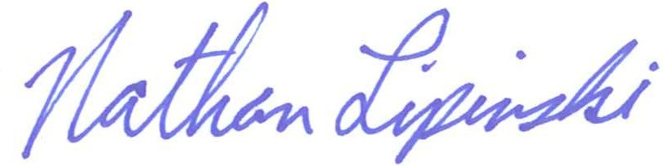
Nathan Lipinski, P.E.
Jewell Associates Engineers, Inc.
enc.
Cc: Howard Crofoot, P.E., City of Platteville Director of Public Works

